Group Name: Cyberspace Lynx

Project Name: Budget Tracking Web Application

Group Members Matric numbers and Names:

Simon Joshua Shunimen: BHU/23/04/09/0034

Daniel David Yakong: BHU/23/04/09/0044

Alpha Aliejuojo Jesse: BHU/23/04/05/0048

Azi Samuel Zachariah: BHU/23/04/09/0026

Anthony Lah-Anre Wakili: BHU/23/04/09/0036

**Project Description and Screenshots**

Project Description: This web application is a budget tracker web app. Basically, it’s made to help out with overspending, extravagance and financial crisis within the midst of people especially among students and workers. It so happens that most people complain about shortage of money, income and earnings on a weekly and monthly basis on the pretext of a low allowance when in reality mismanagement is the problem. So this web app has been developed to keep track of a person’s spending and help to limit.

Firstly, there is the landing page. From here we can navigate to either the login page or register page. 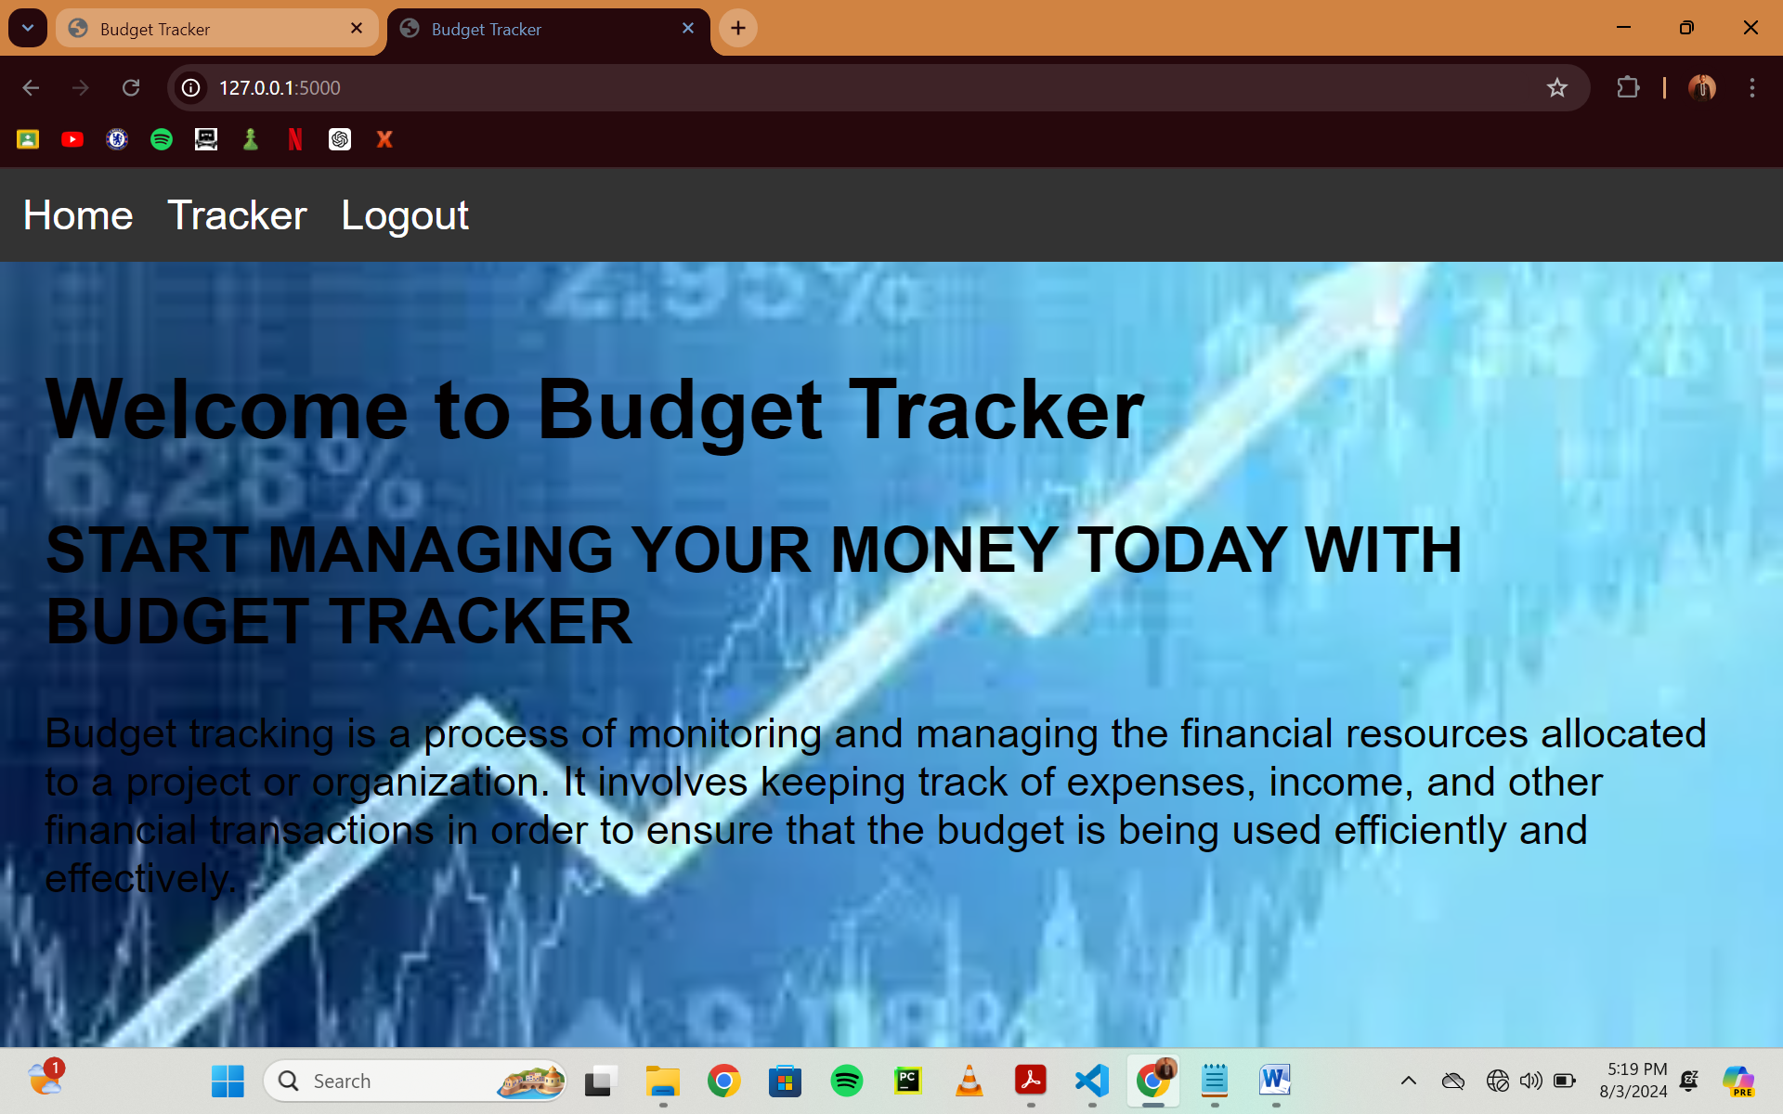

So if the user has been registered before, he or she can move to the login page, but if not, they should move to the Register page.

Now on the Register page, the user is required to input a username and password to register.

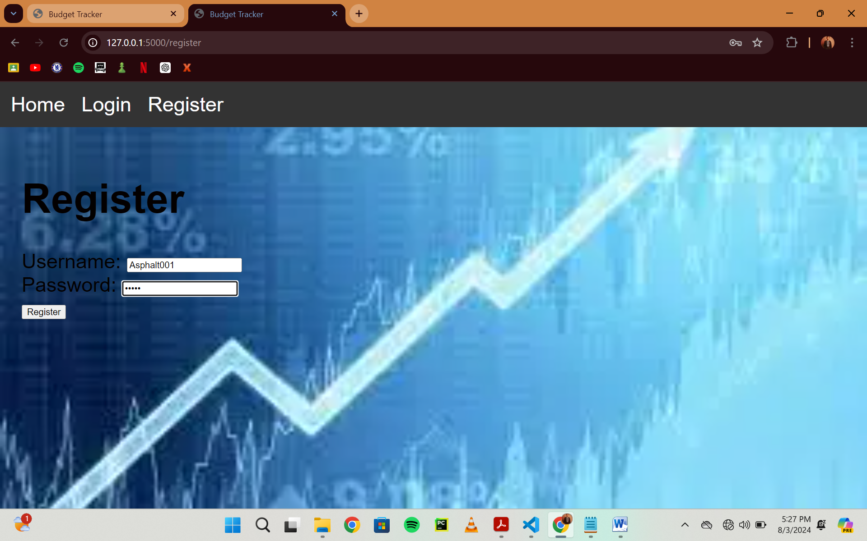

After Registration, it automatically opens the login page which the user will input username and password to get access and if the user is not registered he or she will be denied access.

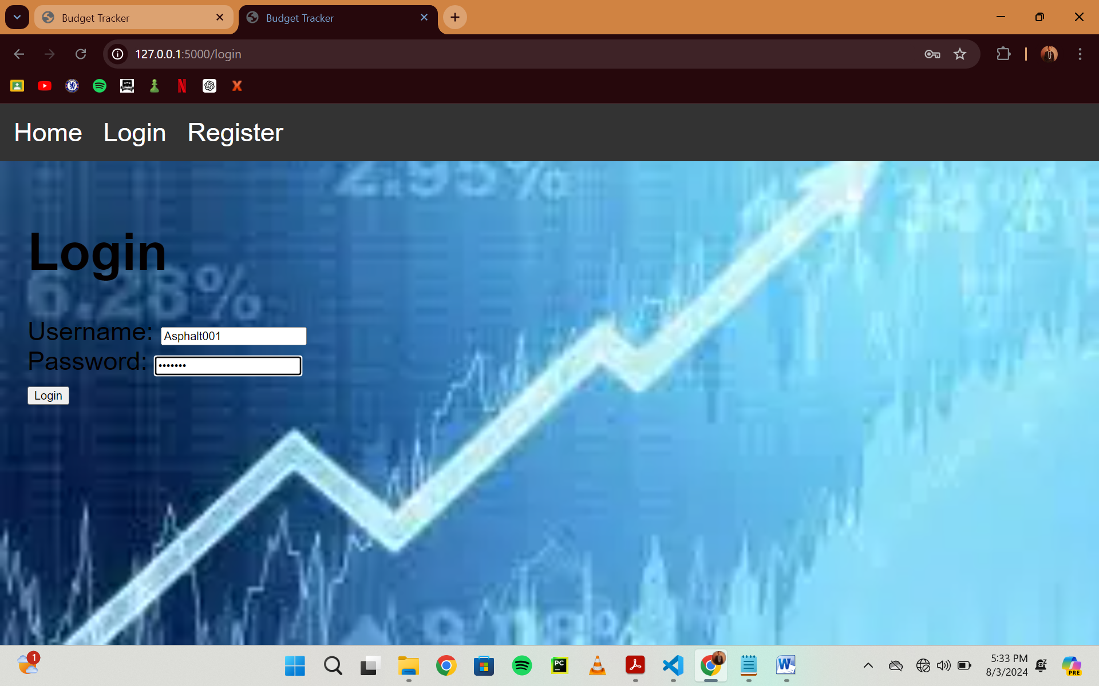

Finally after logging in, the tracker page will be opened immediately. Here you can document your budget amount and description and it will be saved so that it can keep you reminded of the particular amount for whatsoever goods or services it has been allocated.

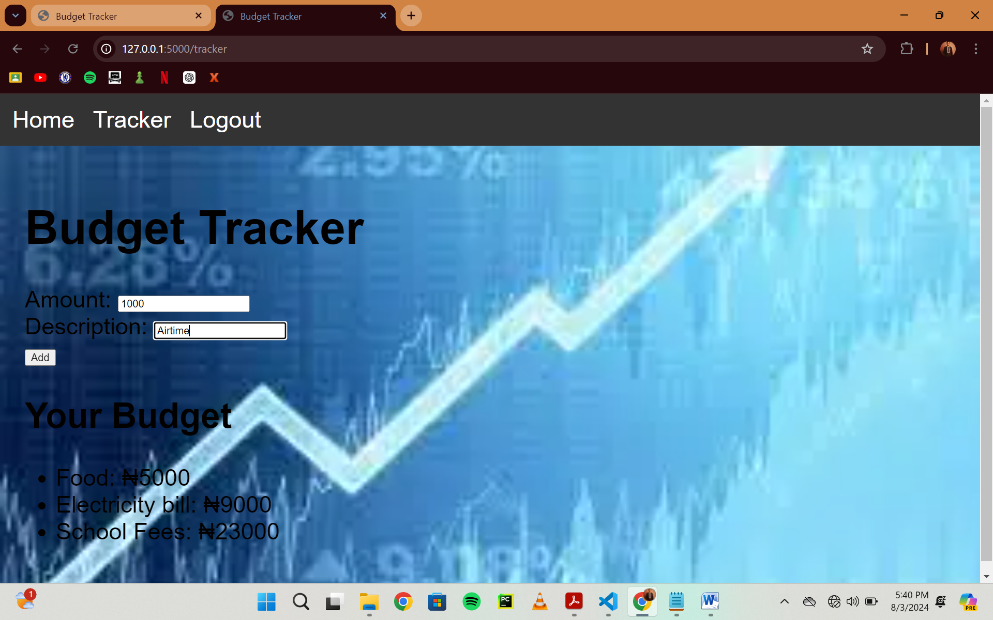

Simon Joshua Shunimen BHU/23/04/09/0034

(Python file) The use of flask to import items and create the Python file in collaboration with the fourth person in group. We made the offline server for the running of the program on a web browser and I arranged register and request form input of the Python file.

David Yakong Daniel BHU/23/04/09/0044

HTML (HyperText Markup Language) is the standard language for creating web pages and web applications. I used html to add style and integrated features to the web app. With html I was able to create the register, login and template of the web app.

Alpha Aliejuojo Jesse BHU/23/04/05/0048

The Use of CSS to set the font type of the Body. Background image was also added and font size was set. The background colors of the navigation bars were also adjusted.

Azi Samuel Zachariah BHU/23/04 /09 /0026

I worked on the login and logout sessions, budget tracking and management, and application startup of the python code. This basically works by verifying the users credentials to allow access to login, logout user after session, manages and displays budget entries, and run the flask application with debugging enabled.

Anthony Lah-Anre Wakili: BHU/23/04/09/0036

I worked on the index.html and base.html ,Which is for the title creation and the wordings added into the web app itself. Also for the title block containing the home, tracker, login, register and log out buttons

